Article

Intelligent Perception for Impact Phase in Hard-Target Penetration based on Time-Series Retained Neural Networks
Jian Zu, Jie Yang and Keren Dai*
School of Mechanical Engineering, Nanjing University of Science and Technology, Nanjing 210094, Jiangsu, China
* Corresponding author email: dkr@njust.edu.cn; ORCID: https://orcid.org/0000-0002-5729-798X
Abstract: During high-speed penetration, missile-borne penetration sensing systems face complex conditions involving multiple materials, varying thicknesses, and variable velocities. The signals acquired by accelerometers exhibit significant differences in morphology, making real-time and accurate identification of the target exit point difficult. This paper addresses the engineering constraints of missile-borne intelligent microsystems by proposing an intelligent perception method for impact phase in hard-target penetration based on time-series retained neural networks. At the sensor data preprocessing level, a refined filtering and dual normalization mechanism targeting highly correlated intervals is designed to eliminate differences in amplitude dimensions across operating conditions and smooth the error surface. At the network architecture level, a strategy of removing the global pooling layer and introducing a temporal flattening operation is proposed, hard-coding the temporal location information of the impact event into the feature arrangement structure, achieving end-to-end accurate regression from the original one-dimensional waveform to the target exit point coordinates. Using metal steel plates and thick concrete walls as penetration targets, the system was validated under 18 different working conditions with three impact velocities and three target thicknesses. Results show that the proposed method achieves a target thickness classification accuracy exceeding 95%, with a maximum mean absolute error of 4.56 mm for steel plates and 19.5 mm for concrete. This method effectively enhances the accuracy and real-time performance of the penetration sensing system in complex dynamic environments while maintaining a lightweight design.
Keywords: hard-target penetration; intelligent perception; time-series retained neural networks; dual normalization

Citation: Zu J, Yang J, Dai K. Intelligent Perception for Impact Phase in Hard-Target Penetration based on Time-Series Retained Neural Networks. Instrumentation, 2026. https://doi.org/10.15878/j.instr.202600407

1 Introduction
In the fields of aerospace and weapon systems, real-time perception of the physical state of a projectile during target penetration is a core technological aspect for achieving optimal detonation decisions. Projectile-borne penetration sensing systems acquire transient impact waveforms generated during projectile-target contact via accelerometers and calculate the penetration state from these waveforms, including target type identification, target thickness estimation, and exit time prediction. This provides crucial decision-making basis for precise fuze detonation. With the increasing demands for precision strikes and intelligent damage in modern battlefields, projectile-borne sensing systems must complete highly reliable state discrimination within extremely short time windows under extreme mechanical environments of strong impact and high overload. This poses stringent challenges to the accuracy, real-time performance, and robustness of sensor signal processing methods[1].
Traditional impact signal processing methods mainly rely on manually designed features such as peak detection, short-time energy analysis, specific frequency band filtering, and threshold-based time-domain discrimination. These methods can achieve acceptable results under relatively fixed operating conditions and with relatively simple signal morphology. However, when a projectile impacts a target at high speed, the acceleration signal collected by the sensing unit varies drastically in amplitude, frequency components, and duration depending on the projectile's velocity, the target material, and the target thickness. For example, in a typical scenario, the signal duration can reach several milliseconds when impacting a concrete target at low speed, while it lasts only a few hundred microseconds when impacting a thin steel plate at high speed; the signal amplitude difference between different target materials can be several times or even tens of times. This variability in signal morphology caused by multi-factor coupling makes traditional identification methods relying on fixed thresholds and manual features difficult to generalize across various conditions. Once the preset calibration conditions are deviated from, the detection accuracy drops sharply[2].
In recent years, signal identification methods represented by deep learning have opened up new avenues for penetration signal processing. One-dimensional convolutional neural networks, with their efficient feature extraction capabilities in time-series signal processing, have been widely applied to tasks such as mechanical fault diagnosis and structural health monitoring, and are gradually being introduced into the field of penetration signal analysis. Kiranyaz et al. systematically reviewed the application of one-dimensional convolutional neural networks in time-series tasks, pointing out their advantages of high computational efficiency and ease of end-to-end training[3]. Ince et al. used a one-dimensional convolutional neural network to achieve real-time motor fault detection, verifying the feasibility of deploying this method in embedded systems[4]. In the field of penetration sensing, existing research has attempted to use CNNs to classify impact signals, identifying different targets or different penetration stages, achieving recognition accuracy superior to traditional methods. However, most existing CNN models are designed for classification tasks, and generally employ techniques at the feature extraction end to compress feature dimensionality, reduce the number of parameters, and prevent overfitting. Global Average Pooling (GAP) operations compress all features along the time axis into a single statistic, which, while beneficial for class determination, completely discards the specific temporal location information of the features. For regression tasks such as target exit point prediction, which require precise temporal location, this loss of location information is fatal. Because the model cannot distinguish whether the target event occurred before or after the signal from the compressed features, the predicted value deviates significantly from the true location. Furthermore, while recurrent neural networks, represented by LSTM and GRU, inherently possess the ability to handle temporal dependencies, their large number of parameters and high inference latency make them difficult to meet the stringent constraints of real-time performance and resource consumption in missile-borne embedded microsystems.
Lightweight network design is a key path for deploying deep learning models to resource-constrained platforms[5,6]. Classic lightweight architectures such as SqueezeNet and MobileNet significantly reduce the number of parameters and computational cost while maintaining accuracy through strategies such as depthwise separable convolutions and channel compression[7,8]. One-dimensional variants of these architectures have been attempted for temporal signal processing on sensor nodes. Saha and Samanta conducted a hardware-aware comparison of LSTM and one-dimensional convolutional neural networks within the TinyML framework. They found that the one-dimensional convolutional neural network consistently achieved approximately 95% accuracy on five benchmark datasets, significantly outperforming LSTM's approximately 89%, while simultaneously reducing RAM usage by 35%, Flash usage by approximately 25%, and inference time by a substantial reduction from 2038 ms to 27.6 ms. This result provides direct empirical support for adopting a one-dimensional convolutional neural network architecture instead of a recurrent neural network architecture in this paper[9]. Xiang et al. proposed DualTime-TCN, a lightweight dual-timescale temporal convolutional network containing only 6.5 × 10⁴ parameters and 2.58 × 10⁶ MACs, achieving a good balance between accuracy and efficiency while maintaining real-time inference capabilities[10]. Mo et al. proposed GLCN, which uses a lightweight CNN architecture for long-term sequence prediction, improving training speed by 65.1% and 86.0% on the Weather and ETTh1 datasets, respectively, while reducing the number of parameters by 94.8% and 94.4%[11]. However, these lightweight networks are designed for spatially independent tasks such as image classification, and their ends all rely on global pooling to eliminate spatial dimensions. When directly transferred to target regression tasks, the global pooling layer will also completely erase the positional structure on the time axis, causing serious prediction bias. Therefore, how to design a network structure that can completely preserve temporal positional information while maintaining model lightweightness is a key problem that urgently needs to be solved in the field of missile impact sensing[12].
To address the above challenges, this paper proposes an intelligent perception method for impact phase in hard-target penetration based on time-series retained neural networks for the engineering constraints of missile-borne intelligent sensing microsystems. Compared with existing work, the main contributions of this study are:
(1) At the sensor data preprocessing level, a preprocessing mechanism that integrates interval fine-tuning and dual normalization is proposed. Unlike general signal standardization methods, this mechanism jointly constrains the input signal and regression label, eliminating the difference in amplitude dimensions across operating conditions and smoothing the error surface of the regression task, allowing the network to focus on learning the relative morphological features that determine the target exit point.
(2) At the network structure design level, a strategy for preserving the temporal position by removing the global pooling layer is proposed. By directly flattening the three-dimensional feature tensor into a one-dimensional vector that preserves the time sequence, the temporal coordinates of the impact event are encoded in the feature arrangement structure, and a dedicated fully connected regression module is designed to complete the end-to-end mapping, achieving accurate regression of the target exit point sequence number while maintaining the model's lightweight nature.
(3) At the experimental verification level, a system test scheme covering 18 operating conditions with two types of targets, three types of target entry velocities, and three types of target thicknesses was constructed. A comprehensive evaluation was conducted from three dimensions: target thickness classification accuracy, target exit point regression error, and embedded inference efficiency, verifying the effectiveness, robustness, and engineering deployment feasibility of the method in complex dynamic environments.

2 System Modeling and Problem Description

2.1 Physical Characteristics of Penetration Impact Signal
Projectile penetration of a target is a transient and highly nonlinear dynamic process. The complexity of its physical mechanism directly maps to the complex form of the sensing signal, posing a fundamental challenge to accurate sensing. From a mechanical perspective, this process can be divided into three physical stages. In the initial impact stage, the projectile contacts the target surface at high speed, generating a huge acceleration pulse in an extremely short time on the order of microseconds. The peak amplitude and the steepness of its rise are determined by both the impact velocity and the surface hardness of the target material, manifesting as a transient spike with extremely high amplitude and extremely wide frequency band in the sensing signal. After entering the stable penetration stage, the projectile overcomes the resistance of the target material and continues to advance within the target. The acceleration signal is formed by the coupling of multiple physical effects such as friction at the projectile-target interface, local fragmentation of the target material, and crack propagation. For homogeneous metal targets, the signal in this stage is relatively regular, exhibiting a quasi-stationary trend of slow decay. However, for non-homogeneous thick concrete targets, the projectile continuously impacts the aggregate along its penetration path, inducing randomly distributed microcracks. This results in a large number of non-stationary random high-frequency oscillations superimposed on the signal, significantly deteriorating the signal-to-noise ratio, and submerging the useful features of the signal in a complex noise background. In the exit phase, the projectile penetrates the target, the back constraint is released instantaneously, and the stress state undergoes a violent unloading. This physical abrupt change manifests in the acceleration signal as a transient amplitude jump or a sudden change in oscillation mode, followed by a rapid decay to zero or the level of ambient noise[13–16].
Under ideal conditions, if the projectile's structural oscillations and measurement noise are not considered, the acceleration signal during the penetration process of a single-layer target can be regarded as a temporal combination of the impact responses of the three physical stages. Let the projectile's entry time be t0 and its exit time be texit, then the ideal acceleration signal can be expressed as:
$a_{ideal}\left(t\right)=a_{imp}\left(t-t_{0}\right)+a_{pen}\left(t\right)+a_{exit}\left(t-t_{exit}\right)$(1)
where a_{imp}(t) represents the transient impact component generated during the initial impact stage, characterized by a large peak with an extremely short rise time. Its amplitude, A_{imp}, is determined by the impact velocity v and the target surface hardness H_{m}, i.e., A_{imp}∝f(v,H_{m}). a_{pen}(t) represents the quasi-stationary acceleration component during the stable penetration stage. For homogeneous metal targets, it can be approximated as a slowly decaying ramp function or a constant value; for non-homogeneous concrete targets, it is superimposed with a large number of random, non-stationary high-frequency oscillations related to aggregate impact. a_{exit}(t) represents the transient unloading response during the exit stage, characterized by a sudden change in amplitude or oscillation mode, followed by rapid decay. The effective duration of each component is strongly coupled by the operating parameter θ=[v,d,m]^{T}, where v is the impact velocity, d is the target thickness, and m is the target type identifier. Ideally, the three stages are distinct on the time axis, and the target exit point can be identified by detecting the abrupt change characteristics of a_{exit}.
The acceleration signal measured by the actual missile-borne sensing system not only includes the ideal impact response, but is also affected by the combined effects of missile structure oscillation, sensor mounting coupling characteristics, and measurement noise. The missile body contains numerous non-rigid connection structures, such as the elastic contact between the sensor and the mounting base, threaded connections, buffer materials, and the gap between the propellant and the casing. These structures will generate elastic oscillations under strong impact excitation, which are transmitted to the sensor through the missile body. Each stage of the structure can be considered as a transmission system with damping characteristics. The transfer function of the j-th structural element is denoted as H_{j}(s). Then, the total transfer function from the impact location to the sensor output is:
$$H_{total}\left(s\right)=H_{1}\left(s\right)⋅H_{2}\left(s\right)⋅⋅⋅H_{m}\left(s\right)$$ | (2)
The corresponding time-domain impulse response is 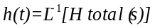. Therefore, the actual acceleration signal can be expressed as the convolution of the ideal impact response and the system's impact response, plus measurement noise:
$$a\left(t\right)=a_{ideal}\left(t\right)*h\left(t\right)+n\left(t\right)$$ | (3)
where ∗ represents the convolution operation, and n(t) represents measurement noise and environmental interference. Due to the damping characteristics of the projectile structure, h(t) often exhibits a damped oscillation form, which can be approximated as:
$$h(t)=A_{h}⋅e^{-αt}\sin{(}ωt+ϕ)$$ | (4)
where A_{h} is the oscillation amplitude, α is the damping attenuation coefficient, ω is the oscillation angular frequency, and ϕ is the initial phase. When the penetration duration is short, especially when the exit unloading response a_{exit} occurs, the structural oscillations excited by the initial impact and penetration process are often not completely attenuated. At this time, the transient characteristics of a_{exit} in equation (1) overlap with the previous oscillation response in the time domain, and the signal characteristics at the exit moment are partially submerged in the background of structural oscillations, resulting in signal confusion.
The above physical process determines that the impact signal has three interrelated characteristics that jointly contribute to the perception difficulty. First, there is a huge dynamic range of signal amplitude between different operating conditions, as shown in Fig. 1. Differences in impact velocity and target hardness can cause signal amplitudes to differ by several times or even more than an order of magnitude under different operating conditions. If these raw signals are directly fed into the processing unit of the sensing system, the large amplitude signal will completely mask the detailed morphological features in the small amplitude signal, making it impossible for subsequent algorithms to establish a unified discrimination criterion. Traditional detection methods that rely on fixed amplitude thresholds will inevitably fail here. Second, the penetration duration is highly variable in the time domain, directly causing a significant drift in the absolute sequence position of the target exit point. The coupling of target thickness and velocity causes the signal length to span from hundreds of microseconds for high-speed thin targets to several milliseconds for low-speed thick targets, a time scale difference of nearly an order of magnitude. This means that the sensing system cannot rely on a fixed time window or absolute sequence position to determine the target exit event, but must learn a relative position expression decoupled from the absolute time scale to identify the end of the penetration process from the evolution of the waveform itself. Even more challenging is the fact that random physical events accompanying the penetration process in heterogeneous targets, such as aggregate impact, crack bifurcation and convergence, introduce numerous non-stationary high-frequency oscillations into the signal. The spectral characteristics of these oscillations often highly overlap with the intrinsic signal characteristics at the moment of target exit, creating natural signal confusion. The sensing system must accurately distinguish between transient mode changes caused by deterministic physical events and local oscillations caused by random processes under such strong interference, avoiding erroneous responses to non-target exit events.

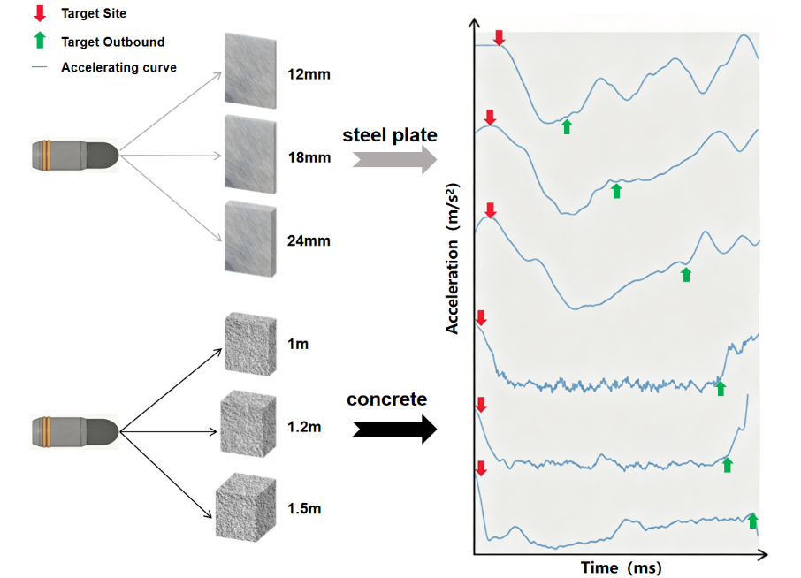

Fig.1 Acceleration signals during penetration under different operating conditions

2.2 Problem Description
Unlike signal processing in a laboratory environment, missile-borne intelligent sensing systems face extremely harsh working environments. Therefore, from the initial design stage, they must confront a series of stringent engineering constraints. These constraints are interdependent and jointly determine the feasible boundaries of the algorithm design. The most critical constraint is real-time performance: from the physical occurrence of the target exit event to the completion of the detonation command, the entire inference process is allocated only a very short time window on the order of microseconds to milliseconds. Any algorithm that cannot complete the calculation within this window, regardless of its accuracy, has no engineering significance. Equally pressing as the real-time constraint is the resource constraint. The computing power, storage space, and power consumption of the missile-borne embedded processor are strictly limited. The number of model parameters and computational complexity must be compressed to an extremely low level, meaning that conventional deep networks or large models are simply not feasible to deploy on the missile-borne platform. Furthermore, the missile-borne sensing system must withstand reliability constraints. Under extreme mechanical environments of strong impact and high overload, the accelerometer itself may experience saturation, zero drift, or even local signal distortion. The sensing algorithm cannot assume the input signal is ideal; it must possess a certain degree of robustness, still providing usable predictions even when signal quality degrades. These three constraints are intertwined, dictating that algorithm design must find a delicate balance between accuracy and efficiency, geared towards engineering deployment[17,18].
It is precisely this requirement for high-precision sensing under extremely constrained conditions that presents the target exit point prediction task with two interconnected core technical challenges. First, the high variability of impact signal morphology under different operating conditions makes establishing a unified discrimination model extremely difficult. Different combinations of ammunition velocity, target material, and target thickness can cause signal amplitudes to differ by more than an order of magnitude, while the duration can extend from hundreds of microseconds to several milliseconds, a span also approaching an order of magnitude. Traditional signal processing pipelines typically rely on manually designed fixed threshold features such as peak detection, short-time energy, or specific frequency band energy. These features may work under certain calibrated conditions, but once the speed, material, or thickness changes, the statistical characteristics of the signal drift, and the discrimination boundary of the manually designed features easily fails. Therefore, sensing systems must have the ability to automatically learn cross-condition invariant morphological features from signals with strong noise and large amplitude jumps, rather than relying on any preset absolute threshold. Secondly, the problem of temporal location information loss that is prevalent in existing lightweight convolutional neural network architectures directly contradicts the requirement for accurate localization in target regression tasks. To compress the number of parameters and prevent overfitting, conventional one-dimensional convolutional neural networks almost invariably use GAP at the feature extraction end, compressing the feature map across the entire time axis into a single statistical vector. This operation is equivalent to completely averaging the occurrence times of the features, and the output has no awareness of the temporal information of the features. For classification tasks that only require outputting category labels, this positional insensitivity is an advantage that enhances robustness. However, for target regression tasks that require outputting precise sequence numbers, it constitutes a fatal flaw: the model cannot distinguish whether the target event occurred before or after the signal from the compressed features, and the predicted values will uncontrollably bias towards the mean of the training set label distribution, causing serious systematic bias. Therefore, how to explicitly preserve the positional structure on the time axis during dimensionality reduction while keeping the model size within the tolerance range of the missile platform is a key challenge that algorithm design must overcome.
In summary, the inherent mechanism of the penetration physical process determines that the sensor signal is a highly dynamic, noisy, and non-stationary time-series data with varying feature scales. This data characteristic directly leads to two core contradictions that must be addressed by intelligent processing methods: first, the contradiction between the incomparability of signal amplitude patterns across operating conditions and the need for stable input features in the regression model; second, the contradiction between the high degree of drift of the target exit time position with operating conditions and the easy loss of time coordinates by lightweight networks during dimensionality reduction. The dual normalization preprocessing mechanism and the time-preserving network architecture that removes global pooling, which are proposed later in this paper, are targeted designs to address these two major contradictions.

3 Algorithm Design Scheme
For the regression prediction task of the target exit point, considering the performance advantages of neural network algorithms in one-dimensional time-series signal processing, and the strict requirements for runtime latency and complexity in high-speed impact application scenarios, this scheme chooses to design a customized lightweight convolutional neural network based on one-dimensional time-series feature extraction[19].
Although traditional deep networks exhibit high learning capabilities, in time-series endpoint prediction tasks that preserve precise location information, the commonly used GAP operation at the end can easily erase the distribution structure of features along the time axis. Therefore, the traditional convolutional network architecture is optimized by explicitly removing the global pooling layer and proposing a novel lightweight architecture that combines multi-scale convolutional kernels with a temporal feature-preserving flattening operation.
First, to efficiently extract local and global features of the time-series signal, the network employs a feature extraction module consisting of three one-dimensional convolutional layers, a batch normalization layer, a ReLU activation layer, and a max-pooling layer. The first convolutional layer uses 16 convolutional kernels of size 1×7 with a padding size of 3. These kernels slide between input features to capture impact features within a wider receptive field. Assuming a one-dimensional input signal of length W and 1 input channel, after the first convolutional layer, the dimension of the output Op1 can be expressed as:
$$\text{Op}\text{1=}\text{Conv}\text{1}\text{D}\text{(}\text{Ip}\text{1)=1×(}\text{W}\text{-}\text{k}\text{+2}\text{p}\text{+1)×}\text{n}$$ | (5)
where k = 7 is the kernel size, p = 3 is the padding size, and n = 16 is the number of output channels. Similarly, subsequent convolutional layers of size 1 × 5 and 1 × 3 are used to further extract abstract features. The ReLU activation function performs zero-point operations on the negative values in the output of the convolutional layer, retaining only the strong positive responses in the feature array. This operation not only enhances the nonlinear expressive power of the output features but also enhances the saliency of the features. The expression of the activation function is:
$$\text{f}\text{(}\text{x}\text{)=}\text{max}\text{(0,}\text{x}\text{)}$$ | (6)
The max pooling layer uses a window of size 2 to downsample the features, further compressing the amount of data in the time dimension, preventing overfitting, improving robustness to changes in feature scale, and providing simplified and generalized input features for the next layer. The expression is:
$${\text{y}}_{\text{i}}\text{=}\underset{{\text{k}}_{\text{w}}\text{-1,}\text{p}\text{=0}}{\text{max}}{{\text{x}}_{\text{i}\text{∙}\text{s}}\text{+}\text{p}}$$ | (7)
Secondly, traditional classification networks typically use convolutional layers and GAP layers to significantly reduce dimensionality and connect classifiers. While this approach is meaningful for tasks without strong spatial and temporal location dependencies, it is not suitable for predicting the specific occurrence node of a one-dimensional time series shock signal. Therefore, this architecture adopts a direct flattening combined with fully connected layers design to replace the “convolutional layer + adaptive average pooling” structure. This change preserves the spatial correspondence between all temporal dimensions and channel features, compensates for the prediction error caused by the loss of location information, and provides greater design flexibility.
Specifically, before entering the fully connected module, all feature outputs of the third convolutional layer are directly flattened into a one-dimensional array. Since the initial input length is reduced to 69 after two pooling downsampling operations, the dimension of the input to the first fully connected layer can be expressed as:
$$\text{F}{\text{C}}_{\text{i}\text{p}\text{1}}\text{=1×(}{\text{C}}_{\text{out}}\text{×}{\text{L}}_{\text{out}}\text{)}$$ | (8)

That is, the total feature dimension is 64×L. Dimensionality reduction is achieved through a two-layer fully connected module: the first fully connected layer reduces the feature dimension to 64 nodes and incorporates a regularization operation with a dropout rate of 0.2 to prevent overfitting; the output dimension of the second fully connected layer becomes 1×1, thus completing end-to-end regression prediction of the signal endpoint location.
While this customized lightweight CNN design significantly optimizes the structure at the algorithmic level, adjustments are still needed in the overall data processing deployment. Firstly, at the data preprocessing level, maximum absolute value normalization is applied to the input signal, and the label endpoint data is mapped to a constraint range between 0 and 1 using a Min-Max scaling strategy. This adaptive data alignment ensures rapid convergence of the mean squared error loss and reduced inference latency under the Adam optimizer. Secondly, the batch normalization layer introduced into the network accelerates training stability while structurally reducing the potential hardware deployment difficulty and resource requirements. Combined with the coordinated design of multi-scale convolutions, this ensures the efficiency and accuracy of the algorithm in extracting features at the impact endpoint.

3.1 Refined Data Selection and Dual Normalization Design
The raw data collected by the accelerometer during target penetration often contains a large amount of redundant interference and cross-scale waveforms. This not only increases the learning burden of the network but also easily leads to unstable regression gradients. Therefore, in terms of data selection and preprocessing, this scheme proposes a refined data selection and dual normalization mechanism for specific intervals, as shown in Fig. 2, which significantly improves the model's adaptability to changes in the amplitude of the impact signal.

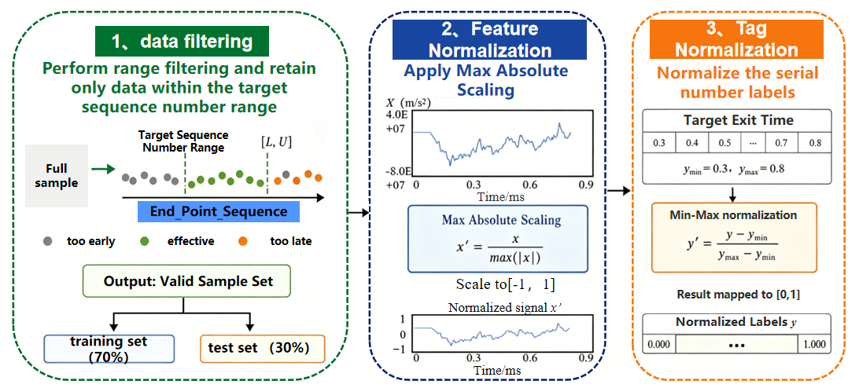

Fig.2 Flowchart of refined data selection and dual normalization

The penetration impact signal dataset used in this study is jointly constructed based on LS-PrePost (LS-PrePost 4.8 x64 2021, LSTC) finite element simulation and Wasserstein Generative Adversarial Network with Gradient Penalty (WGAN-GP). All simulations and model training were conducted on a computer equipped with an Intel Core i5-12600KF CPU, 32 GB DDR4 RAM, and a single NVIDIA GeForce RTX 4060 GPU. First, a three-dimensional model of a typical projectile-initiated system is established using SolidWorks. In LS-PrePost, material constitutive models are assigned to components such as the projectile body, fuze, explosive charge, circuit board, and target plate. The target plate uses the MAT_PIECEWISE_LINEAR_PLASTICITY model to reflect large plastic deformation and ductile damage under high strain rates. Orthogonal simulations were conducted on two target materials: ship steel plates (12 mm, 18 mm, 24 mm thick) and thick concrete targets (1000 mm, 1200 mm, 1500 mm thick). Simulations were performed at three impact velocities: low (300 m/s), medium (500 m/s), and high (800 m/s). Basic simulation samples were obtained for each scenario. To meet the data requirements of deep learning while controlling time costs, the WGAN-GP framework was introduced for data augmentation. This framework uses Wasserstein distance instead of the traditional JS divergence metric to measure the difference between the generated distribution and the true distribution, and incorporates a gradient penalty mechanism to stabilize the training process, avoiding mode collapse and gradient anomaly issues. The generator uses random noise as input to generate new impact signals, while the discriminator approximates the distribution distance using a scoring method. Both are iteratively optimized during adversarial training. An additional total variation smoothing loss is introduced in the generator to suppress high-frequency jitter in the generated signal. After training, a generator was used to expand each working condition to 2000 sets of impact signal samples, ultimately forming a dataset covering 18 working conditions and a total of 36,000 signal sequences.
To ensure the model highly focuses on the core physical processes occurring at the impact endpoint, a strict interval filtering barrier was first established in the preprocessing stage of the entire dataset. By evaluating the distribution characteristics of the signal labels, the algorithm systematically eliminated outlier samples that were too early or too late, forcibly extracting data segments whose label endpoints strictly fell within the target sequence numbers. This refined screening strategy effectively removed invalid trailing oscillations and background noise without triggering significance. After rigorous cross-filtering, high-confidence valid samples were finally obtained. To verify the model's generalization performance, these valid samples were randomly divided into training and test sets in a 7:3 ratio, providing a solid data foundation for subsequent model optimization.
Under penetration conditions, the absolute acceleration amplitude of the impact signal often varies by several times or even tens of times. If the original amplitude is directly fed into the network, the convolution kernel is easily dominated by large amplitude signals, thus ignoring the temporal morphological features hidden in the waveform fluctuations. To address this phenomenon, a scaling mechanism based on the maximum absolute value is adopted for the input signal X. Specifically, after extracting each set of one-dimensional time-series signals, the algorithm dynamically retrieves the global extremum of the absolute value of the signal segment and uses it as the denominator to perform a division operation on the entire signal segment:
$${\text{X}}_{\text{norm}}\text{=}\frac{\text{X}}{\text{max}\text{(|}\text{X}\text{|)}}$$ | (9)
Through this operation, all array signals are uniformly scaled to the dimensionless interval [−1, 1]. The choice of maximum absolute value normalization (MAU) over Z-score normalization or RobustScaler is based on the following theoretical considerations. For accelerated impact signals, the physical zero point and sign (positive or negative) of their amplitude have clear physical meaning—positive and negative correspond to the direction of acceleration, respectively. Z-score normalization destroys this property, forcibly shifting the signal mean to zero, causing the originally physically meaningful zero-level point to lose its reference frame. More importantly, the scaling factor of Z-score is the standard deviation, which causes high-velocity or hard target signals with drastic amplitude fluctuations to be over-compressed after normalization, while low-velocity or soft target signals with gentle amplitudes are relatively amplified, resulting in a distortion of the signal-to-noise ratio structure of the network input under different operating conditions. MAU completely eliminates the difference in amplitude magnitude while perfectly preserving the peak-valley shape, zero-crossing moments, and transient jump characteristics of the signal waveform.
Regarding gradient propagation, constraining the input to [−1, 1] ensures that the input norm of all samples is on the same order of magnitude, which helps maintain the stability of the convolutional layer gradient. If the input magnitude range is too large, the gradients of deep networks may explode or vanish due to the multiplication effect; while a uniform input scale keeps the Lipschitz constants of the gradients of each layer within a controllable range, thereby accelerating the convergence of the Adam optimizer. This mechanism perfectly preserves the peak and trough morphology, frequency distribution, and transient jump characteristics of the impact signal on the time axis, while completely eliminating the dimensional differences caused by different absolute amplitudes, allowing the network layer to focus on learning the "relative morphological features" that determine the endpoint position.
In addition to constraining the input features, when solving regression problems that directly output specific sequence numbers, neural networks usually face problems such as unstable mean square error calculation and slow convergence due to large numerical ranges. To address this, the solution introduces a dedicated Min-Max normalization strategy for the output label Y. Based on the data boundary characteristics of the filtering interval, the true endpoint sequence number is shifted and compressed into the target interval of 0~1. The specific mapping formula is:
$${\text{Y}}_{\text{norm}}\text{=}\frac{{\text{Y}}_{\text{true}}\text{-}{\text{Y}}_{\text{min}}}{{\text{Y}}_{\text{max}}\text{-}{\text{Y}}_{\text{min}}}$$ | (10)
This label space transformation reduces the original order of hundreds to the floating-point range, greatly smoothing the error surface and enabling the Adam optimizer to provide a more stable and uniform gradient update amplitude during backpropagation, avoiding gradient divergence in the early stages of the regression task. Simultaneously, to ensure the closed-loop integrity of the entire prediction system, the algorithm designs corresponding denormalization restoration operations during the verification and evaluation phases. The predicted values output by the network are remapped back to the true physical sequence space:
$$Y_{pred}=Y_{pred_{norm}}×(Y_{max}-Y_{min)}+Y_{min}$$ | (11)
Finally, the system calculates the mean absolute error and root mean square error based on the restored true sequence number, thereby ensuring that the output results have direct physical guidance significance during hardware deployment.

3.2 Temporal Position Preservation and Refined Regression Strategy Based on Removing the Global Pooling Layer
In classic lightweight convolutional neural networks, GAP layers or adaptive average pooling layers are often used at the network ends to replace the role of fully connected layers. This design is highly advantageous in signal classification or image recognition tasks because it can average and compress features across the entire time series or spatial dimension, thereby significantly reducing the number of model parameters and suppressing overfitting[20–22]. However, for the high-precision regression task of "predicting the target exit point" in this paper, the global pooling operation has a fatal flaw: while averaging features, it completely erases the precise location information of the feature distribution along the time axis. Let the convolutional output feature map be F. The operation of global average pooling on this feature map can be expressed as:
$$GAP\left(F\right)={\left[\frac{1}{T}\sum_{t=1}^{T}{f_{1}\left(t\right),…,\frac{1}{T}\sum_{t=1}^{T}{f_{C}\left(t\right)}}\right]}^{T}$$ | (12)
This operation satisfies any permutation π on the time axis:
$$\frac{1}{T}\sum_{t=1}^{T}{f_{c}}\left(π\left(t\right)\right)=\frac{1}{T}\sum_{t=1}^{T}{f_{c}}\left(t\right)$$ | (13)
That is, GAP is a permutation-invariant operator. For classification tasks that only need to output class labels, this property can enhance robustness; however, for regression tasks that require precise temporal coordinates, the network cannot distinguish the specific time of the target event from the compressed C-dimensional vector, constituting a fundamental information bottleneck. At the gradient propagation level, GAP evenly distributes the loss gradient to each time step, making it difficult for the network to specifically strengthen key moments. In contrast, the flattening operation maps F to a (C,T)-dimensional vector, and the gradient can be traced back to a specific time point, with each time step independently receiving an update signal matching its contribution. From the perspective of information bottleneck, GAP has a compression ratio as high as T:1, with more than 98% of the temporal location information being irreversibly discarded; flattening, on the other hand, completely preserves the entire temporal structure, providing sufficient decision-making basis for subsequent regression.
Therefore, to preserve strict temporal coordinates while extracting deep features, this scheme specifically reshapes and optimizes the traditional CNN architecture, as shown in Fig. 3.

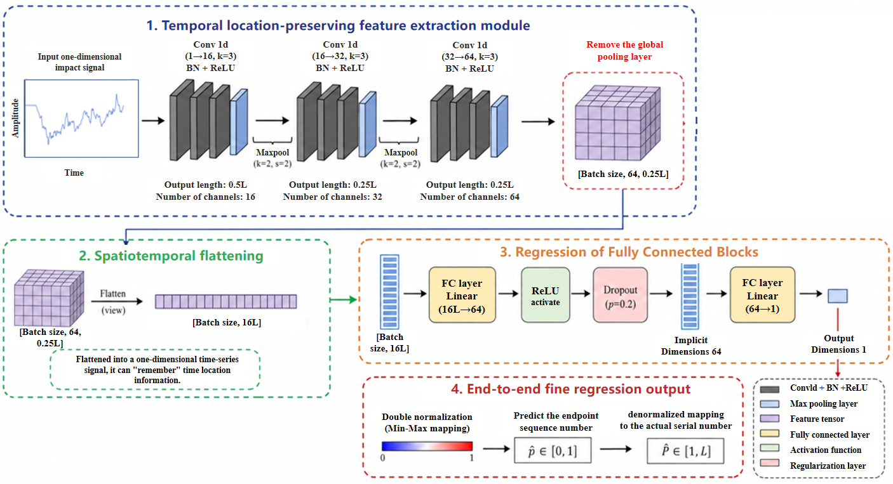

Fig.3 Flowchart of the refined regression network with global pooling removal

To overcome the limitations of traditional classification network architectures on regression tasks, this model explicitly removes the original GAP module at the algorithm code level after completing the three-layer cascaded feature extraction. After processing by the pre-convolutional module, the original input signal of length L is downsampled by two max-pooling layers, compressing the temporal length to 0.25×L, while expanding the number of feature channels to 64. After abandoning global pooling, the network employs a direct flattening operation, directly unfolding the multidimensional feature tensor into a one-dimensional vector while preserving its original temporal order. This reshaping strategy not only preserves the local high-frequency abrupt changes in the impact signal at specific time points but also hard-encodes the temporal location information of these features into the order of the unfolded vector, laying the structural foundation for subsequent accurate coordinate regression.
After temporal flattening, the total dimension of the flattened features output by the network reaches 64×0.25×L. To efficiently process this high-dimensional feature vector containing strict positional information and map it to a single sequence number scalar, a dedicated regression fully connected module is designed in the backend of the model. This module first projects the massive 16L-dimensional feature group to 64 hidden nodes through a first linear fully connected layer. Considering the potential overfitting risk caused by the surge in model parameters after removing the global pooling layer, this hidden layer is immediately followed by a ReLU nonlinear activation function and a regularization layer with a dropout rate of 0.2. By randomly deactivating some neurons during training, the network is forced to learn more accurate distribution features.
After dimensionality reduction and regularization, the final 64-dimensional hidden features are fed into the last linear layer with one output node. This node directly outputs the predicted floating-point value after dual normalization, thus completing the end-to-end fine regression task from the one-dimensional impact signal input to the endpoint position coordinate output. This redesigned architecture of "convolution to extract features + removal of global pooling to preserve position + fully connected fine mapping" successfully solves the bottleneck of traditional lightweight networks in position-sensitive tasks, achieving high inference accuracy while accurately regressing the endpoint sequence number of the impact signal.

4 Results Analysis
To comprehensively verify the generalization ability of the proposed target exit point identification scheme under different physical materials and complex working conditions, we conducted parallel comparative experiments on datasets of two materials with more complex acoustic properties: metal steel plates and concrete, with different target entry velocities and material thicknesses. The velocities were grouped as low speed (300 m/s), medium speed (500 m/s), and high speed (800 m/s); the steel plate thicknesses were 12 mm, 18 mm, and 24 mm; and the concrete thicknesses were 1000 mm, 1200 mm, and 1500 mm.

4.1 Target Thickness Classification Performance Analysis
Target thickness classification, as a prerequisite for target exit point regression, directly determines the accuracy of the physical scale range mapped by the subsequent regression. Under all 18 working conditions, the model was tested for classification and identification on datasets of three target thicknesses under the same velocity and target material conditions. The results are as follows:

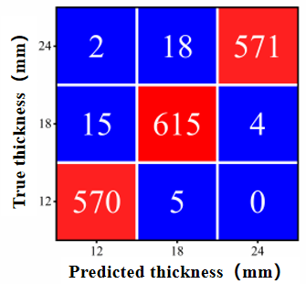  a. low-speed steel plate | 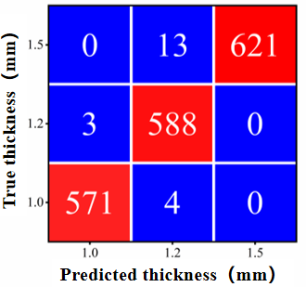  b. low-speed concrete | 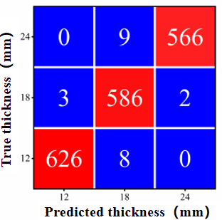  c. medium-speed steel plate
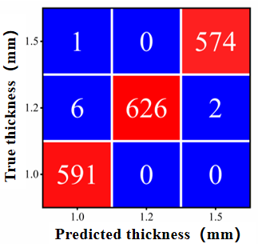  d. medium-speed concrete | 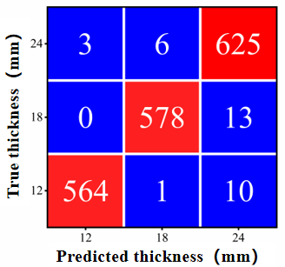  e. high-speed steel plate | 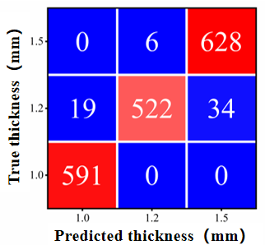  f. high-speed concrete
Fig.4 Confusion matrix for target thickness recognition under different speeds and materials

As shown in Fig. 4, the classification accuracy for all conditions is higher than 95%. For steel plate targets, the classification accuracy reaches 97.6%, 98.8%, and 98.2% at low, medium, and high speeds, respectively, while for concrete targets it is 99.1%, 98.9%, and 96.7%, respectively. This indicates that the designed feature extraction module can stably capture discriminative information related to target thickness from the waveform morphology.
From the perspective of target material, the overall classification accuracy for the three thicknesses of steel plates is slightly higher than that of concrete, and the confusion pattern between categories is more uniform. For concrete targets, the confusion level between the 1000 mm and 1200 mm adjacent thickness categories is slightly higher than other adjacent pairs, while the 1500 mm category maintains a high degree of discriminability. This phenomenon is closely related to the physical characteristics of the penetration process of heterogeneous targets: during the penetration of concrete targets, the random collisions between the projectile and aggregate introduce a large number of non-stationary high-frequency oscillations into the signal. The statistical characteristics of these oscillations at thicknesses of 1000 mm and 1200 mm may differ less than their intra-class variance, thus blurring the distinction boundary between adjacent thicknesses. However, the penetration duration of a 1500 mm thick target is significantly longer, and the accumulated morphological differences are sufficient for the network to clearly distinguish it from the first two categories. Based on the misclassified samples, it can be found that the vast majority of misclassifications occur between adjacent thickness categories, with cross-thickness misclassifications being extremely rare. In steel plate targets, the probability of misclassifying an 18 mm target as a 24 mm target is slightly higher than that of misclassifying a 12 mm target. This is related to the gradually decreasing target exit time increment corresponding to equal thickness increments at medium to high thicknesses. As the penetration rate decreases with increasing target thickness, the relationship between the increase in signal duration and target thickness becomes non-linear, and the characteristic interval between adjacent thicknesses narrows. Concrete targets exhibit the same trend, with greater confusion between 1200 mm and 1500 mm targets compared to 1000 mm and 1200 mm targets. The underlying physical mechanism lies in the significant attenuation of projectile kinetic energy during the later stages of penetration by thick concrete targets. While the penetration time increment per unit thickness increases, the rate of change in signal morphology slows down, equivalent to a reduction in the distance between adjacent categories in the feature space. From a velocity perspective, the target thickness classification accuracy does not show a systematic trend with increasing or decreasing target velocity. The average accuracy across the three velocities is similar, indicating that the dual normalization preprocessing effectively eliminates the coupling effect of velocity changes on signal amplitude and time scale, and the discriminative features extracted by the network exhibit good invariance to velocity factors.

4.2 Accuracy Analysis of Target Exit Point Regression
Target exit point regression is the final output of the entire sensing task, and its accuracy directly affects the precision of the final detonation point. Assuming correct target thickness classification, the model performed end-to-end sequence number regression of target exit points for all working conditions. The regression error statistics are shown in Fig. 5:

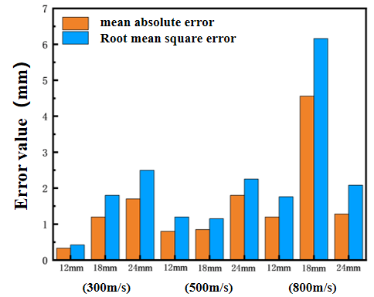  a. steel plate target | 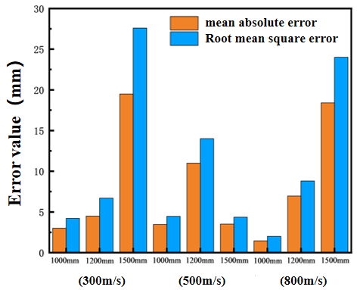  b. concrete target
Fig.5 Prediction error of target exit point for two types of targets

The maximum mean absolute error for steel plates is 4.56 mm, occurring in the high-speed 18 mm condition; the maximum mean absolute error for concrete targets is 19.5 mm, occurring in the low-speed 1500 mm condition. The near-order-of-magnitude difference in accuracy between the two types of targets is a significant feature across all conditions. This stems from the fundamental difference in the physical processes of penetration: the stress unloading at the moment of exit point for steel plates manifests as a clear transient amplitude jump, allowing the network to locate this event with high spatial accuracy; however, concrete penetration involves multiple random physical processes such as aggregate impact and crack propagation. The exit point unloading often manifests as a gradual change in oscillation mode rather than a transient jump in the acceleration signal, significantly overlapping with the non-stationary oscillations during the penetration process in the frequency domain, making identification far more difficult than for the steel plate condition.
The specific regression prediction results scatter plots are shown in Fig. 6 and Fig. 7:

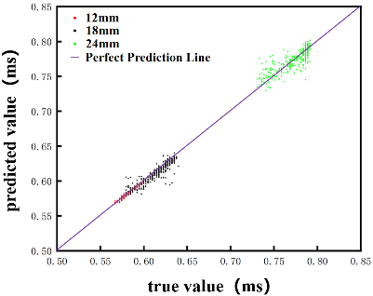  a. low-speed (300 m/s) | 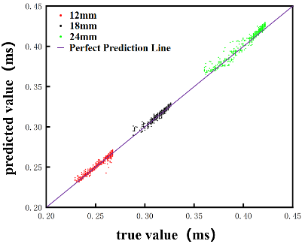  b. medium-speed (500 m/s) | 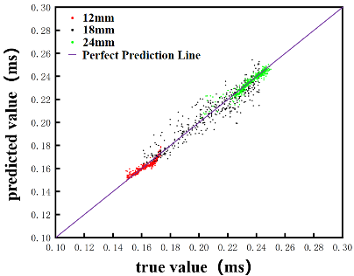  c. high-speed (800 m/s)
Fig.6 Scatter plot of steel plate target exit point identification results at low, medium and high speeds

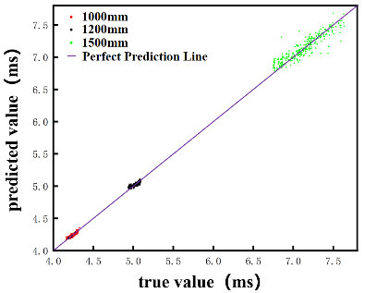  a. low-speed (300 m/s) | 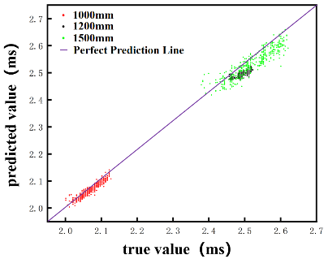  b. medium-speed (500 m/s) | 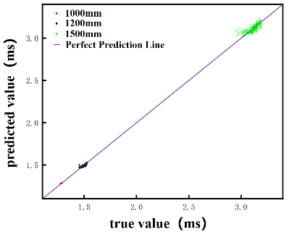  c. high-speed (800 m/s)
Fig.7 Scatter plot of concrete target exit point identification results at low, medium and high speeds
Fig. 6 and Fig. 7 show that the error distribution along the target thickness dimension exhibits a consistent upward trend. For steel plate targets, the 12 mm thin target has the smallest error. Taking low speed as an example, the target exit point is concentrated between 0.57 and 0.6 ms, and the regression prediction point is basically consistent with the actual target exit point, with an average absolute error of only 0.33 mm and a root mean square error of 0.42 mm. When the thickness increases to 18 mm, the target exit point is distributed between 0.58 and 0.64 ms, and the prediction result shows a band-like pattern, with a small portion scattered outside the band. The average absolute error rises to 1.2 mm, and the root mean square error is 1.8 mm. For the 24 mm thick target, the target exit point is concentrated between 0.73 and 0.8 ms. As the number of premature exit samples decreases, the model's learning from the preceding data weakens, leading to more discrete predictions in this area, with an average absolute error reaching 1.7 mm and a root mean square error of 2.5 mm. The concrete target also exhibits a trend of increasing mean absolute error with target thickness: for a 1000 mm target, the distribution range of the target exit point shifts with velocity. At low speeds, it is concentrated between 4.13 and 4.3 ms, with the prediction results appearing as a band attached to the ideal line, with a mean absolute error of 3 mm and a root mean square error of 4.2 mm. At medium speeds, the target exit point shifts to 1.98–2.13 ms, with a mean absolute error of 3.45 mm. At high speeds, the target exit point height is concentrated between 1.26 and 1.28 ms, with a mean absolute error of only 1.44 mm. When the thickness increases to 1200 mm, the dispersion of the target exit point distribution increases significantly, the model learning effect weakens, the prediction band widens, and the mean absolute error rises to 4.5 mm at low speeds, 11 mm at medium speeds, and 6.96 mm at high speeds. Under the condition of a target thickness of 1500 mm, the target exit points at low speeds are scattered across a wide range of 6.7–7.74 ms, resulting in a discrete and blurred prediction band, with the mean absolute error increasing to 19.5 mm and the root mean square error reaching 27.6 mm. At medium speeds, the target exit points concentrate at 2.45–2.55 ms, and the model's prediction accuracy recovers somewhat, with a mean absolute error of 3.5 mm. At high speeds, the target exit points are distributed between 2.95–3.2 ms with the dispersion intensifying again, and the mean absolute error reaching 18.4 mm. This series of data indicates that increasing the target thickness prolongs the penetration duration and also extends the time window for the accumulation of random disturbances in the signal. For concrete targets, a longer penetration path means more aggregate impact events, leading to a gradual deterioration of the signal-to-interference ratio at exit time, and the network's ability to extract patterns from noise approaches its resolution limit.
The effect of velocity on error exhibits non-monotonic characteristics related to the target material. For steel plate targets, the mean absolute error of the 12 mm thin target increased from 0.33 mm at low speed to 0.8 mm at medium speed and 1.2 mm at high speed. For the 18 mm target, the mean absolute error was 1.2 mm at low speed, decreased to 0.85 mm at medium speed, and then jumped to 4.56 mm at high speed. For the 24 mm target, the mean absolute error at the three speeds was 1.7 mm, 1.8 mm, and 1.28 mm, respectively, with relatively gradual changes. Overall, the error of the steel plate target was slightly higher at medium and high speeds than at low speeds. This is because high-speed penetration shortens the total signal duration, compressing the relative interval between the target exit jump and the initial impact peak, thus narrowing the time window for network discrimination. Concrete targets showed the opposite trend: the mean absolute error at low speeds was often higher than at medium and high speeds, especially under the thickest target conditions: the mean absolute error of the 1500 mm target was 19.5 mm at low speeds, only 3.5 mm at medium speeds, and 18.4 mm at high speeds. Low-speed penetration makes the projectile's interaction with the aggregate in the concrete target more random, with a larger proportion of the effect from a single aggregate impact. This increases the ratio of local oscillation amplitude to exit jump amplitude in the signal, and increases the probability that exit characteristics are masked by strong local oscillations. Under high-speed penetration conditions, the projectile penetrates the target with higher kinetic energy, the aggregate is broken up more uniformly, the penetration process tends to be stable, the random oscillation component of the signal is relatively weakened, and the discernibility of the exit moment is actually improved. The opposite performance of the two target materials in the velocity dimension suggests that the optimization direction of the penetration sensing system needs to be differentiated according to the target material type.
The distribution pattern of the prediction error further reveals the predictive characteristics of the model. The error distribution in the steel plate case is approximately a symmetrical single-peak shape centered at zero, with positive and negative errors roughly balanced. The model's prediction of the target exit point is unbiased, without any systematic tendency to lead or lag. The error distribution in the concrete case, however, is slightly shifted towards positive values overall, especially under low-speed thick target conditions, indicating that a few samples have a systematic lag where the predicted value is greater than the actual value. By examining the signal waveforms of these delayed prediction samples, it can be observed that the acceleration unloading jump amplitude is relatively small near the target exit moment, while the amplitude of the local oscillation peak caused by a certain aggregate impact in the later stage of penetration is actually higher. The model made an incorrect choice between two signal patterns with similar characteristics but vastly different physical meanings. The difficulty lies essentially in the signal confusion at the physical level, rather than a flaw in the algorithm design.

5 Conclusion
This paper addresses the challenge of real-time and accurate target identification in missile-borne penetration sensing scenarios, particularly under conditions involving multiple materials, varying thicknesses, and variable velocities. It proposes an intelligent impact signal processing method that integrates physical simulation, data augmentation, and lightweight deep learning, forming a complete technical solution encompassing multi-condition data simulation, signal preprocessing, and precise neural network identification.
At the data level, we jointly constructed an impact signal dataset covering 18 working conditions, including two target materials (steel plate and concrete), three target thicknesses, and three impact velocities, using LS-DYNA finite element simulation and WGAN-GP generative adversarial network. This provides a data foundation with both physical realism and sufficient scale for the training and validation of the penetration sensing algorithm. At the signal preprocessing level, a refined interval filtering and dual normalization mechanism are proposed: the former rigorously eliminates invalid trailing oscillations and background noise through label distribution evaluation, while the latter applies maximum absolute value scaling to the input signal and Min-Max mapping to the regression labels, eliminating the interference of cross-condition amplitude dimension differences on sensing feature extraction and smoothing the error surface of the regression task. At the perception algorithm architecture level, a lightweight regression strategy that preserves temporal location information is proposed. By removing the global pooling layer at the end of feature extraction and employing spatiotemporal flattening, the time coordinates of the impact event are fully preserved in the feature arrangement structure, overcoming the prediction offset problem caused by the loss of temporal information in traditional lightweight networks in position-sensitive regression tasks.
System experimental results under 18 conditions show that the method achieves a classification accuracy of over 95% for different target thicknesses under the same speed and target material. The maximum mean absolute error for target exit point regression prediction is 4.56 mm, and the maximum root mean square error is 6.16 mm for steel plate targets, while the maximum mean absolute error for concrete targets is 19.5 mm, and the maximum root mean square error is 27.6 mm. This technical solution boasts low computational cost and a simple structure, providing a feasible lightweight solution for real-time target exit sensing and reliable detonation control of next-generation missile-borne intelligent fuses. Future work will focus on multi-axis acceleration fusion sensing, online adaptive migration of unknown target conditions, and integrated sensor-computing hardware deployment.

Author Contributions:
J.Z.: conceptualization, methodology, validation, writing – original draft.
J.Y.: conceptualization, investigation.
K.D.: resources, supervision.

Funding Information:
This research received no external funding.

Data Availability:
The data supporting the findings of this study are not publicly available due to their use in ongoing follow-up research. However, the data are available from the corresponding author upon reasonable request with the permission of the research team.

Conflict of Interest:
The authors declare no competing interests.

Ethics Statement:
Not applicable.

Use of Generative AI and AI-Assisted Technologies:
The authors declare that no generative AI or AI-assisted technologies were used in the preparation of this manuscript.

References
- Sui L, Zhang Z, Yu H, et al. Optimal Design and Experimental Study of a Layer Counting Sensor for High-Speed Penetration Through Multilayer Hard Targets[J]. IEEE Sensors Journal, 2025, 25(13): 23781–23792.
- Siljama O, Koskinen T, Jessen-Juhler O, et al. Automated flaw detection in multi-channel phased array ultrasonic data using machine learning[J]. Journal of Nondestructive Evaluation, 2021, 40(3): 67.
- Kiranyaz S, Avci O, Abdeljaber O, et al. 1D convolutional neural networks and applications: A survey[J]. Mechanical Systems and Signal Processing, 2021, 151: 107398.
- Ince T, Kiranyaz S, Eren L, et al. Real-time motor fault detection by 1-D convolutional neural networks[J]. IEEE Transactions on Industrial Electronics, 2016, 63(11): 7067–7075.
- Zhang D, Hao X, Wang D, et al. An efficient lightweight convolutional neural network for industrial surface defect detection[J]. Artificial Intelligence Review, 2023, 56(9): 10651–10677.
- Shen H, Wang Z, Zhang J, et al. L-Net: A lightweight convolutional neural network for devices with low computing power[J]. Information Sciences, 2024, 660: 120131.
- Iandola F N, Han S, Moskewicz M W, et al. SqueezeNet: AlexNet-level accuracy with 50x fewer parameters and <0.5 MB model size[J]. arXiv preprint arXiv:1602.07360, 2016.
- Kulkarni U, Meena S M, Gurlahosur S V, et al. Quantization friendly mobilenet (qf-mobilenet) architecture for vision based applications on embedded platforms[J]. Neural Networks, 2021, 136: 28–39.
- Saha B, Samanta R. Rethinking Temporal Models for TinyML: LSTM versus 1D-CNN in Resource-Constrained Devices[J]. arXiv preprint arXiv:2603.04860, 2026.
- Xiang X, Wang J, Han Z, et al. High-accuracy real-time mixed-gas concentration prediction using a dual-timescale temporal convolutional network[J]. Microchemical Journal, 2026: 117853.
- Mo S, Yang C, Mo Y, et al. From global to local: A lightweight CNN approach for long-term time series forecasting[J]. Computers and Electrical Engineering, 2025, 123: 110192.
- Fang A, Li R. Penetration Fuze Accurate Layer Recognition Neural Network Data Enhancement Method[J]. Journal of Detection & Control, 2022, 44(1): 1–6.
- Yu D, Yang B, Yan K, et al. Dynamic transfer model and applications of a penetrating projectile‐fuze multibody system[J]. International Journal of Mechanical System Dynamics, 2023, 3(4): 360–372.
- Zhang S, Kong X, Fang Q, et al. The maximum penetration depth of hypervelocity projectile penetration into concrete targets: Experimental and numerical investigation[J]. International Journal of Impact Engineering, 2023, 181: 104734.
- Cao S, Fan J. Numerical model for penetration process of a deformable projectile into ductile metallic target plate considering the interaction of projectile and target[J]. International Journal of Impact Engineering, 2025, 195: 105107.
- Yang Y, Kong X, Tang J, et al. Experimental and numerical investigation on projectile penetration resistance of prefabricated concrete targets[J]. International Journal of Impact Engineering, 2024, 193: 105053.
- Wu J, Liu C, Li T, et al. Real-time signal processing method of ultra-wideband fuze using LSTM[C]//Journal of Physics: Conference Series. IOP Publishing, 2023, 2478(2): 022020.
- Luo Y, Hou J, Shi X, et al. Real-time Signal Processing of UWB Fuze Based On 1D-CNN Model[C]//Journal of Physics: Conference Series. IOP Publishing, 2023, 2478(2): 022021.
- Xu H, Tian Y, Ren H, et al. A lightweight channel and time attention enhanced 1D CNN model for environmental sound classification[J]. Expert Systems with Applications, 2024, 249: 123768.
- Lin M, Chen Q, Yan S. Network in network[J]. arXiv preprint arXiv:1312.4400, 2013.
- Stergiou A, Poppe R. Adapool: Exponential adaptive pooling for information-retaining downsampling[J]. IEEE Transactions on Image Processing, 2022, 32: 251–266.
- Zhao L, Zhang Z. A improved pooling method for convolutional neural networks[J]. Scientific Reports, 2024, 14(1): 1589.

